COMP 2681

Devan Houston & Ashley Lindbergh

2019-04-26

Business Description:

For our project we agreed to create a coffee shop website, we decided on this because coffee shops are a prevalent and far spread industry around the world offering an enticing website project, utilizing appealing design and functionality. Our business is 404 Coffee Place. A youth, tech-sector oriented coffee shop located in metropolitan areas offering diverse brands of coffee with 24-hour service and delivery. Promoting a yearly “International Coffee Day” charity discount, every October 1st.

Project Objectives:

Our objective in making this project was to test our web design and coding skills. We wanted to create a functional prototype website that draws from the basic functionality of international, national, and local coffee shops. We’ve taken aesthetic design inspiration from larger brands and have constructed our prototype to compete with the likes of The Art We Are Café, and other rural/local businesses.

Site Map:

Home Page:

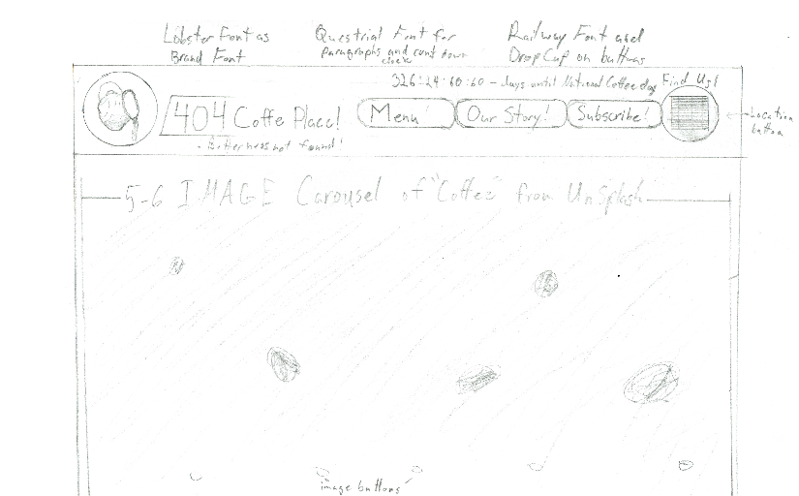

Home Page Continued (re-purposed into menu page as-well):

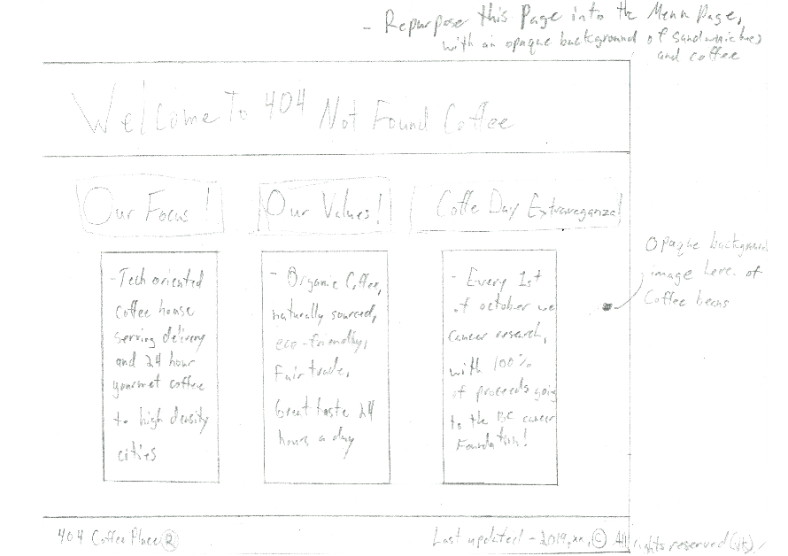

Subscribe Page:

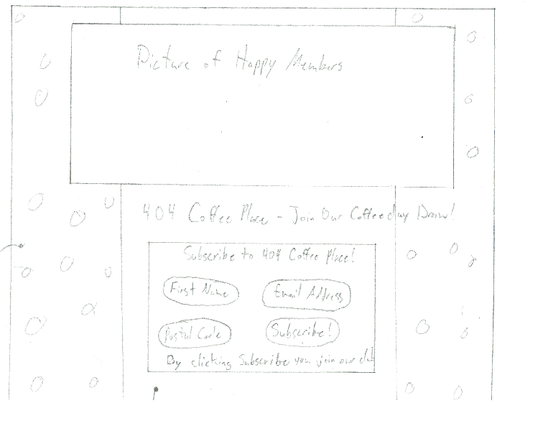

How A Business Would Benefit:

Any local business without a website could utilize this prototype website. We designed this website after a coffee shop for the duality of re-purposing the website into nearly any other commercial food service. The website currently offers a platform to deliver news and product information to users, and to subscribe to a news letter.